**LAB ASSIGMENT – 2.5**

**PROMPT:**

* **TASK 1 :** Refactoring Odd/Even Logic (List Version):
* **Scenario:** You are improving legacy code.
* **Task:** Write a program to calculate the sum of odd and even numbers in a list,then refactor it using AI.
* **Expected Output:** Original and improved code

**PROMPT:**

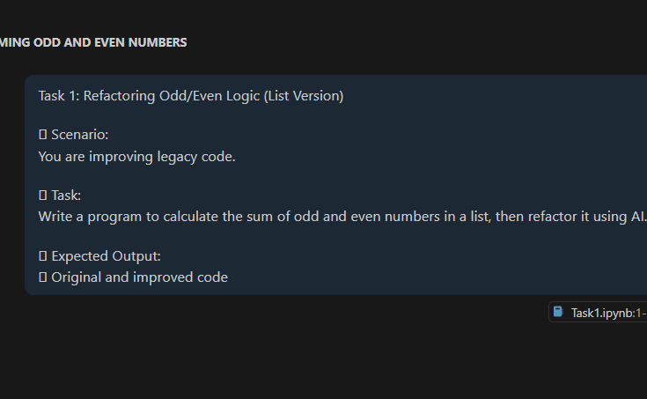

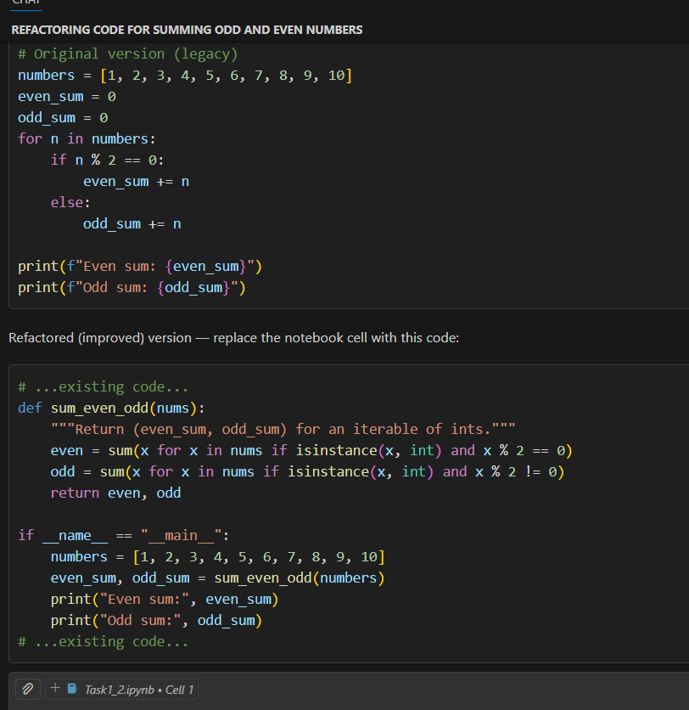

**Original version:**

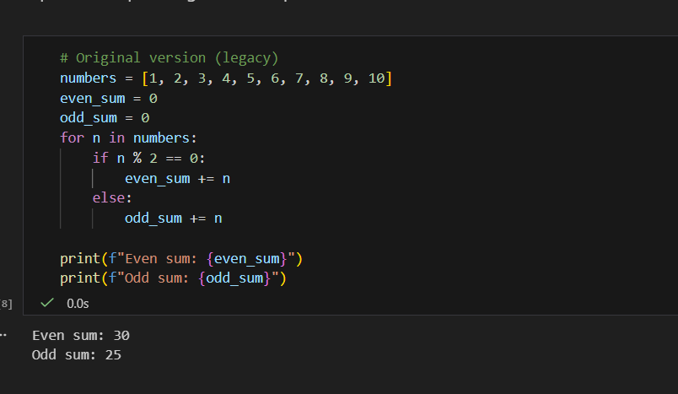

**Reference Code:**

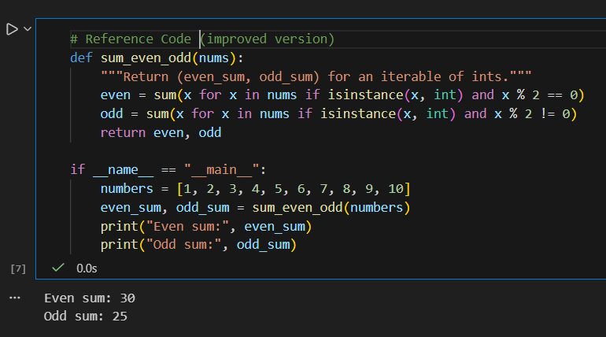

**Expected Output:**

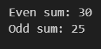

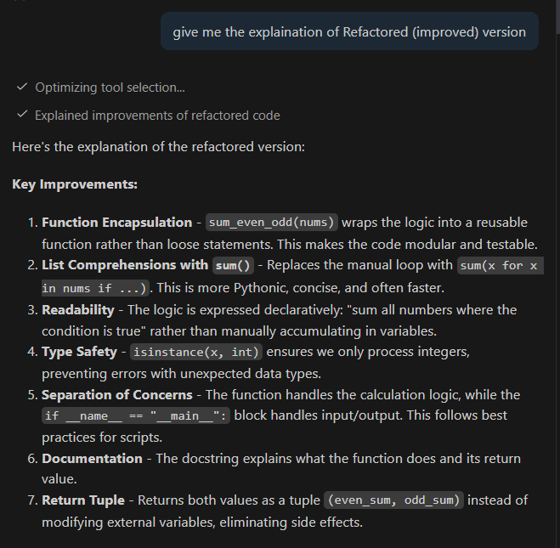**Explanation:**

**PROMPT:**

**Task 2: Area Calculation Explanation**

* **Scenario:**You are onboarding a junior developer.
* **Task:**Ask Gemini to explain a function that calculates the area of different shapes.
* **Expected Output:**
  + Code
  + Explanation

**PROMPT:**

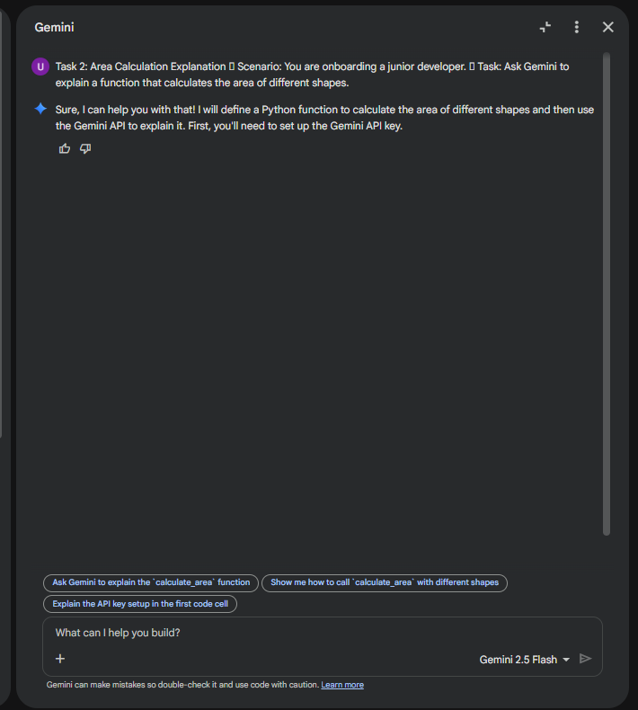

**Expected Output:**

**Code:**

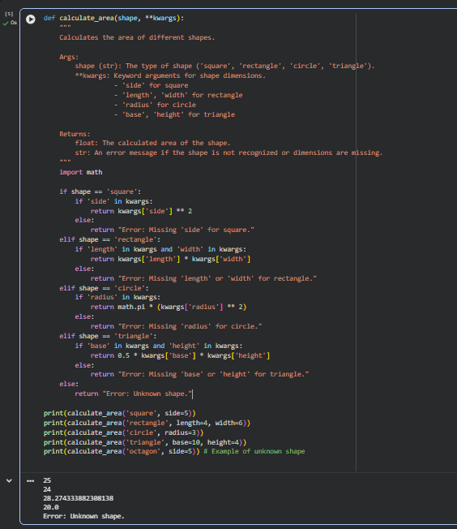

**Expected Output:**

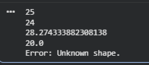

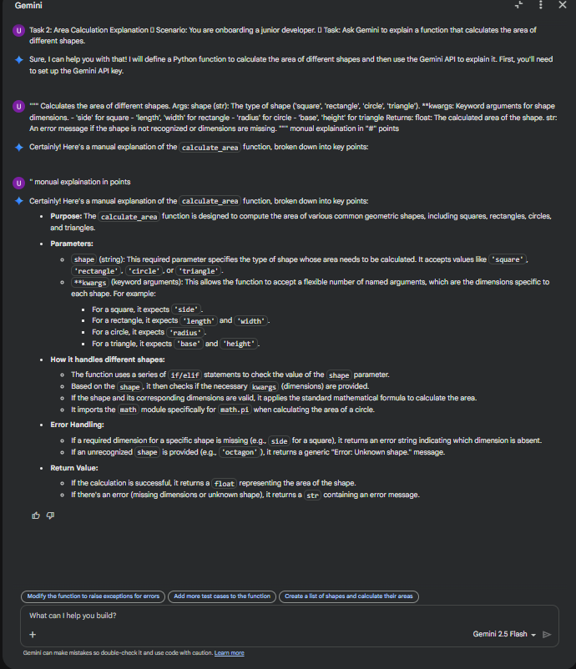**Explanation:**

**PROMPT:**

**Task 3: Prompt Sensitivity Experiment**

* **Scenario:**You are testing how AI responds to different prompts.
* **Task:**Use Cursor AI with different prompts for the same problem and observe code changes.
* **Expected Output:**
  + Prompt list
  + Code variations

**Cursor AI Prompt:**

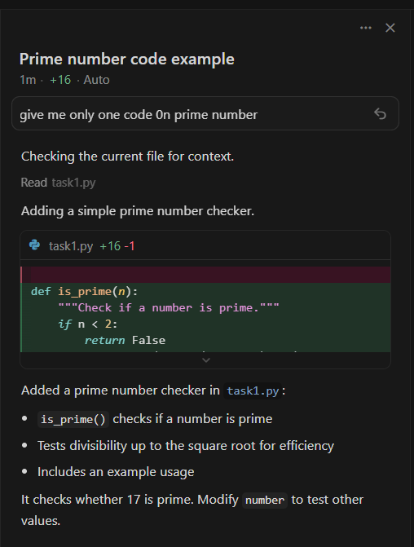

**GitHub Copilot:**

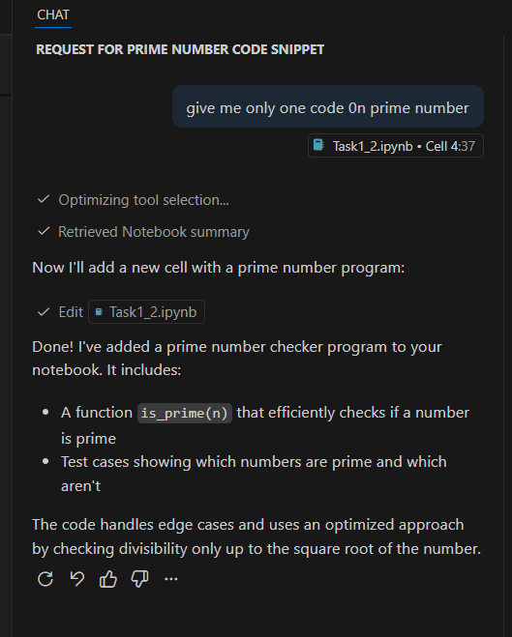

**Cursor AI Code Variations:**

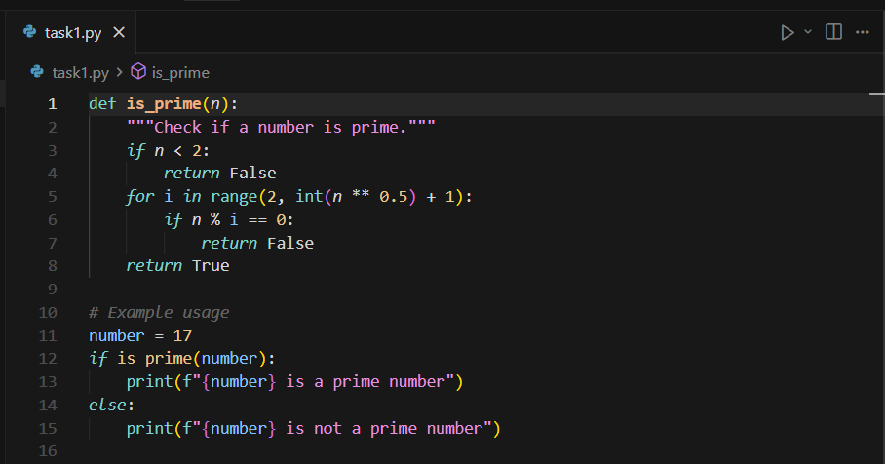

**Output:**

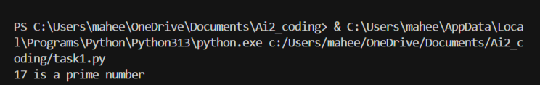

**GitHub Copilot Code Variations :**

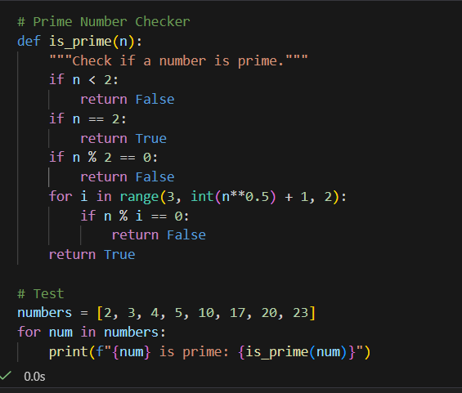

**Output:**

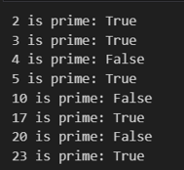

**Explanation Of Cursor AI Code:**

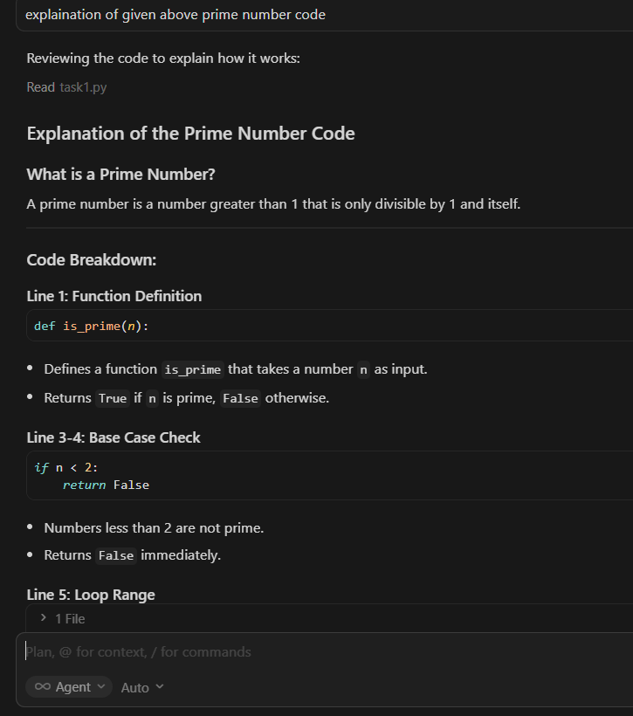

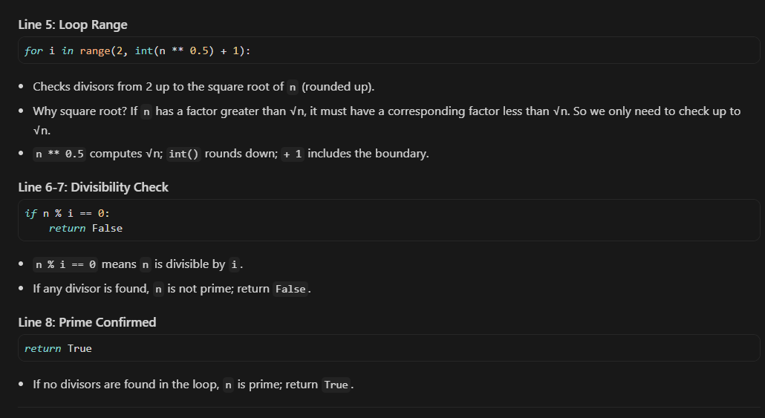

**Explanation Of GitHub Copilot Code:**

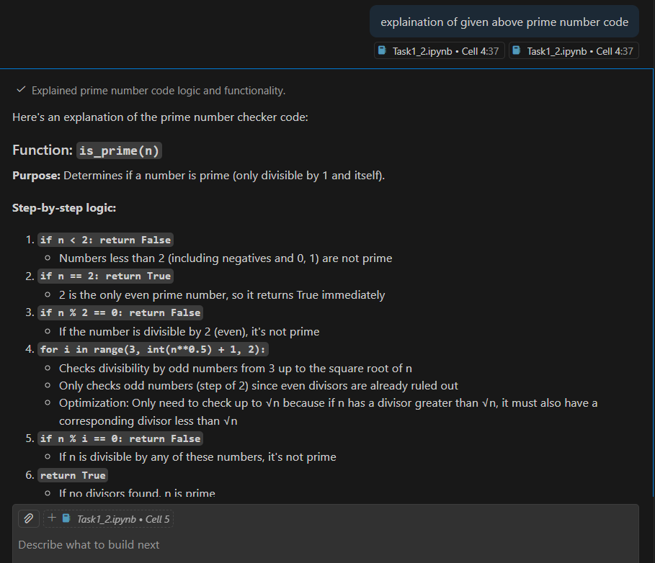

**Task 4: Tool Comparison Reflection**

* **Scenario:**You must recommend an AI coding tool.
* **Task:**Based on your work in this topic, compare Gemini, Copilot, and Cursor AI for usability and code quality.
* **Expected Output:**

Short written reflection

**Task 4 : Tool Comparison Reflection Recommendations :**

**● If you are a student or researcher**: Use Gemini. The free tier is generous, and its ability to explain "why" is unmatched for learning**.**

**● If you work in a large enterprise**: Stick with Copilot. The security, GitHub integration, and "set it and forget it" nature make it the safest bet.

**● If you are building a product from scratch:** Use Cursor. The ability to refactor across multiple files at once will save you hundreds of hours of manual "plumbing."